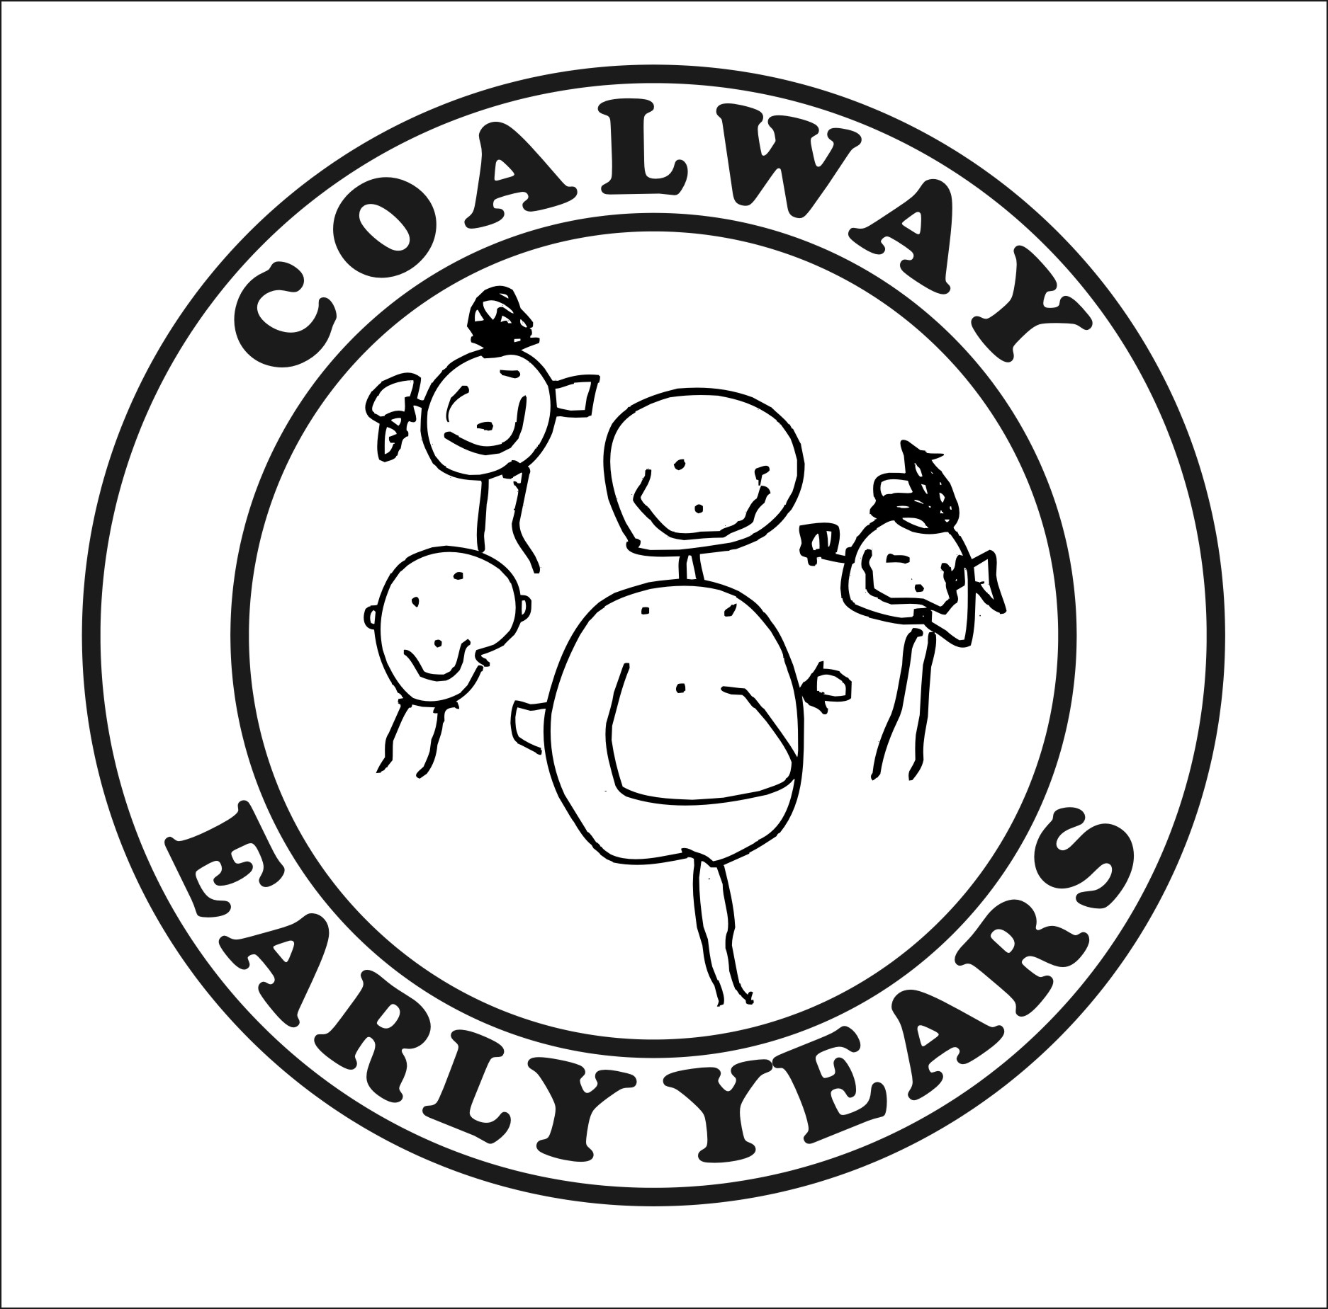

Data Privacy Notice
For Parents/Carers

Our Information Commissioner’s Office (ICO) registration number is

We are a Data Controller for your personal data, which means that we decide what information we need to keep about you and why, and how we process and store that information.

What personal data do we keep and process?

When you register your child for the setting we ask you to complete a registration form which may include personal data. Personal data can only be viewed and processed by relevant staff. Data about children is classified as ‘sensitive’ and we take extra care to keep it safe.

What do we use your personal data for?

Personal data is used to help us to best care for your child/children. We also use relevant data to enable us to receive Nursery Education Funding and to fulfil our contract with you e.g. processing payments.

How is your personal data stored?

Your personal data is stored in the following ways: (e.g. Password-protected PC, Locked filing cabinet, Tapestry or online system, Accident records etc.)

(If you are using online services such as Tapestry or an online server i.e. Cloud storage you should list them here and check and state that they are also GDPR compliant.)

We will not share your personal data with any other third party without your permission.

Coalway Early Years and Your Personal Data

We need to keep certain personal identifiable information (PIP) about parents and children who use our service in order to fulfil our contractual obligations and best care for your children. From 25 May 2018 the processing of this personal information is governed by the General Data Protection Regulation (GDPR) 2018.

We only collect personal data when we have a lawful reason for doing so, and we only use it for the purpose it was originally obtained for. We take steps to ensure that the data we keep is accurate, up to date and secure, and we do not keep it for any longer than is necessary. We have written policies and procedures in place for dealing with personal data, including breaches of security, and our staff have appropriate training and awareness of data protection principles and procedures.

Our Data Protection Lead is Jo Young (Finance Officer).

Our Information Commissioner’s Office (ICO) registration number is Z2475042

We are a Data Controller for your personal data, which means that we decide what information we need to keep about you and why, and how we process and store that information.

What personal data do we keep and process?
When you register your child at Coalway Early Years we ask you to complete a registration form which includes personal data about your child/ren and the parents/carers.
- Child’s name
- Child’s date of birth
- Parent(s)/Carer(s) names
- Parent(S)/Carer(s) address and contact details i.e phone numbers and email address’
- Details of siblings
- Details of parental responsibility
- Emergency contact details
- Medical Information (including name and contacts for other agencies eg; doctor, dentist and health visitor)
- Signatures for consent
- Children’s photos

Personal data is also collected to allow us to claim nursery educational funding, a declaration form is completed and signed by a parent/carer.
- Child’s name
- Child’s date of birth
- Parent/carer names
- Child’s address
- Parent/carer address
- Parent/carer national insurance number
- Parent/carer date of birth

Personal data can only be viewed and processed by relevant staff. Data about children is classified as ‘sensitive’ and we take extra care to keep it safe.

What do we use your personal data for?
Personal data is used to help us to provide best care and education for your child/children. We also use relevant data to enable us to receive Nursery Education Funding and to fulfil our contract with you e.g processing payments.

How is your personal data stored?
All personal information held is stored securely.

- Paperwork, containing personal information is stored within locked filing cabinets
- Devices i.e cameras and tablets with photographs of children are stored within locked cabinets at the end of every day.
- Children’s Learning journals to support children’s learning and development are stored on Tapestry, our secure password protected, online system which is accessible by staff and relatives, where permission has been given by the parent/s / legal guardian/s - printouts relating to tracking are kept in locked cabinets
- Photographs (anonymous) are used on our website, where permission has been given from the parent(s)/legal guardian(s)
- Communication between professional agencies are sent via a secure email system – Egress
- Personal information to claim funding is stored on the secure Gloucestershire County Council funding portal
- Electronic files containing children’s information will be password encrypted on a password-protected PC and may be stored on an encrypted USB or files are password protected.
- With the consent of parents, photographs of children are displayed on our display boards, reflective diary and website.
- Names are used for children to identify their pegs/drawers for personal belongings.
- Where relevant, allergy information is on display within the child’s base room and medical forms are stored with medication within the child’s base room in individual children’s medical bag.

All third parties have been checked and are GDPR compliant.

What is the legal basis for processing your personal data?
Your data is processed on the basis of your contract with us for the care of your child.

How long do we keep your personal data for?
We keep your personal data as long as your child is enrolled in our setting. After your child has left there is some data that we are required to keep under statutory regulations. You can see view retention of records guidelines if required. All photos are deleted within 3 months of the child leaving the setting and Tapestry online journals are deactivated - a USB of the child’s learning journey is available to purchase when they leave the setting.

What are your rights with regard to your personal data?

Under the GDPR you have the right to:
- Know what personal data we keep about you.
- Request a copy of the personal data we hold about you.
- Request that we correct any personal data which is found to be inaccurate or out of date.
- Request that we erase any personal data where it is no longer necessary for us to keep that data.
- Request us to transmit the personal data that we hold about you to another data controller. (This right only applies where the processing we do is by your consent or for the processing of a contract, and where that processing is by automatic means.)
- Withdraw your consent for processing to which you have previously given your consent. (Please note that if you do this it may affect our ability to fulfil our contract with you).

Who to contact
If you have any queries or complaints, or wish to exercise any of the above rights, please contact Jo, our Data Protection Lead:

Name: Kayleigh Hoskings

Email: bcplaygroup@btinternet.com

Telephone: 01594 839436

