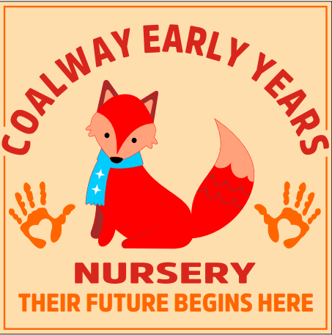
At Coalway Early Years we are committed to ensuring that all children that attend are safe when eating during snack and mealtimes.

The purpose of this policy is to ensure that all children in our care are provided with a safe eating environment that supports Healthy eating, minimises food-related risks, and ensures compliance with the Early Years Foundation Stage (EYFS) statutory framework 2025.

Key Principles
- Ensure all meals and snacks given to the children are nutritious, well-balanced and cater to individual dietary needs.
- To promote healthy eating from an early age
- Safeguard children from food related risks, including choking hazards and food allergies.

Safer Eating Practices.

To minimise the risk of choking and ensure safe eating environments for young children, the following practices are implemented:

• Supervision: All children are supervised during mealtimes and snack time. There will always be a member of staff in the room with a valid paediatric first aid certificate when eating. Children will be within sight and hearing of a member of staff whilst eating. Where possible, staff will sit facing children whilst they eat so they can be sure children are eating in a way to prevent choking and so they can prevent food sharing and be aware of any unexpected allergic reactions.
• Choking Hazards: The setting will ensure that they inform parents of the correct, safe way to prepare food that prevents choking and be vigilant to ensure foods sent in packed lunches have also been prepared safely. Firm, spherical foods like grapes and cherry tomatoes must be sliced into quarters or segments. Cylindrical foods such as cucumber, carrots and cocktail sausages must be cut lengthways into thin batons. This guidance on food safety for young children – https://help-for-early-years-providers.education.gov.uk/safeguarding-and-welfare/food safety includes advice on food and drink to avoid, how to reduce the risk of choking and links to other useful resources for early years settings. If a child experiences a choking incident that requires intervention, staff will record details of where and how the child choked and parents and/or carers will be made aware. The records will be reviewed and risk assessed alongside other accidents / incidents at nursery on a half-termly basis. Appropriate action will be taken to address any identified concerns.
• Mealtime Environment: Children will sit down and remain seated while eating and be given time to chew and swallow their food properly. Children are discouraged from talking loudly at mealtimes / snack time. Other distractions such as toys at the meal table are, wherever possible, discouraged. Food sharing is not allowed.

Food Allergies and special dietary requirements.

At Coalway Early Years we recognise the importance of catering to children’s dietary needs, including food allergies and intolerances. All food allergies or special dietary requirements MUST be disclosed to the nursery by parents/carers on the settings “Registration form” BEFORE a child starts at the setting.

- Record Keeping – We maintain up-to-date records of children’s allergies/intolerances and dietary preferences. The information shared with all members of staff and also transferred to the child’s Placemats. We will prompt parents to update the information we hold regarding special dietary needs every 6 months.
- Risk Assessment - A thorough risk assessment is carried out for children with food allergies, ensuring appropriate precautions are taken, including avoiding allergens in meals and snacks.
- Responsibility – At each meal time/ snack time practitioners will ensure items are checked before they are given to the child. It is the responsibility of the parent to ensure that the child’s lunch box is suitable and safe for the child to eat.
- Prohibited foods – Nuts, nut products, sweets, chocolate bars and chocolate spreads are not permitted at Coalway Early Years.

Training and awareness.

Staff will receive regular training in Paediatric first aid, Food Hygiene level 3 and allergy awareness.

- First aid and emergency procedures – All staff will be training in procedures specific to food related incidents such as choking and how to handle an allergic reaction. First aid will be updated at least every 3 years as a minimum.
- All staff are required to complete training as part of their induction covering food hygiene and allergy awareness. All staff will be aware of the symptoms and treatment of allergies and Anaphylaxis, the differences between allergies and intolerances and that children can develop allergies at any time.
- Ongoing Training – Staff will undergo refresher courses on food hygiene and allergy awareness every two years as a minimum.

This policy was adopted on | Signed (nursery manager)
18/09/2025 | Signed (Chair or Committee)
Date for review |  | Date for review
Date for review |  | Date for review

