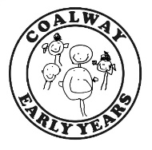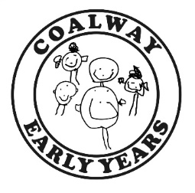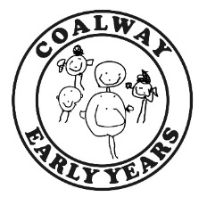

**It’s All About Me!**

I live with...

Please complete this form on behalf of your child, we use this information to help your child settle in and it informs us of their ‘starting point.’

My Name is...

I like to be called ...

I am…

(Age in months)

My start date is…

I have some pets and they are…

When I am tired I will…

You can help me by …

When I feel upset I…

These actions or comforters help calm me down…

These are my favourite things I like to play with at my house…

My parents/carers would describe me as…

*e.g. confident, shy etc.*

I like to drink milk and water in a

Bottle / lidded cup/ open cup

The things I can do by myself are...

*e.g. use the toilet, dress myself, wash my hands.*

Things I like to play with are…

Paint / Sand / Water / Messy Play

I communicate my needs through

Gesture / babble / words / sentences

My favourite nursery rhymes/ songs/ stories are…

My favourite things to eat are...

Things I don’t like are…

My Parents/Carers may also like to tell you more about me…

**Mark with a tick where appropriate**



Enjoys playing with small world toys.

Talks about and explores colour.

Takes part in pretend play.

Enjoys exploring how things work.

Builds and constructs.

Uses large muscle movements.

Can use the toilet

independently.

Can follow some rules.

Asks for help when needed.

Can share, with support.

Likes to play cooperatively.

Is beginning to develop friendships with other children.

Able to listen to others.

Enjoys carrying out small tasks.

Shows affection towards

people who are special to them.

Leaves carer with growing confidence.

