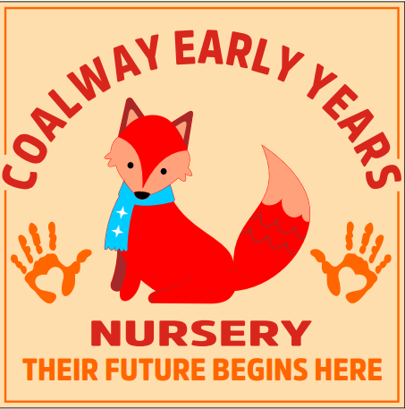
Welcome to ‘Coalway Early Years’

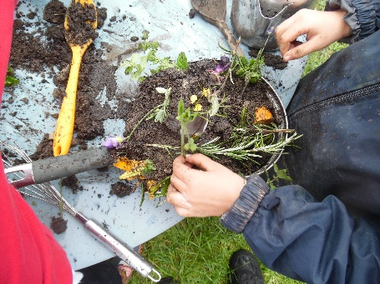
​At Coalway Early Years we offer excellent education and care for children aged 2, 3 and 4 years. We provide a safe and nurturing environment where children are supported to reach their full potential. We strive to support every child in our care. As part of our curriculum, we encourage children to become Skilled communicators, independent, confident, successful learners and a compassionate citizen, who have confidence in their own abilities, and we encourage and reward the children’s willingness to try new things. Practitioners encourage children to ‘have a go’ to enable them to feel pride in their attempts and to develop an ability to learn new skills.

Our ‘family’ atmosphere enables children to settle quickly with Practitioners supporting their emotional well-being exceptionally well; children develop a sense of security which allows them to excel in all areas of their development.

We are open on a term time only basis, 38 weeks of the year, following the term times and inset days in line with Coalway Infant and Junior Schools. The setting is a committee run, non-profit charity and we are registered with OFSTED under the Children’s Act 1989.

Our nursery is set up with two base rooms, We have our Squirrels room, that is for children aged 2 and the younger 3 year olds. When they are ready they then transition through to our pre-school room which is the last year with us before the children head off to school. This room is called our Penguin room.

We provide a large, open plan environment with natural light and resources, there is access to toilets from their base room. We have areas set up within the room that focus on the various aspects of the curriculum, for example art, mark-making, and construction. In addition, we provide quieter, more enclosed spaces for cosy, reflective learning opportunities such as role-play, conversation and storytelling. Our large outdoor play area provides fun and challenging teaching and learning opportunities that include a "mud kitchen", gardening area, outdoor creative arts area, and "loose parts" to promote problem solving and construction on a larger scale.
We have our own Nature Area in the school grounds and are very lucky to also be able to access a wide range of other environments and experiences provided by the schools - this includes use of the school hall and field for P.E, a large 'trim-trail', and playground area for riding bikes.
We balance our daily routines between extended periods of child-led play (Busy time) to help the children develop their own ideas and interests, and adult led experiences that enable us to offer more focused teaching activities. Our aim is to provide stimulating, open-ended activities that promote social interaction, independent learning and critical thinking skills. We are continuously evaluating and improving our learning environment to ensure we maintain outstanding teaching and learning so that every child attending can fulfil their potential.
Session Times

We are open Monday to Friday (during term-time) and you may choose from full day sessions (9am to 3pm) or half day sessions (9am to 12pm; 12pm to 3pm). We also work closely with ‘Coalway Kids Club’ who offer extended care for children from the term after their third birthday, supporting families who need ‘wrap around care’. We do ask that children are all brought in for 9am, ready to learn, If you are running late, please can you drop off for 9.30am – this is to avoid disruption to our registration time.

Daily Routine

A typical day at ‘Coalway Early Years’……
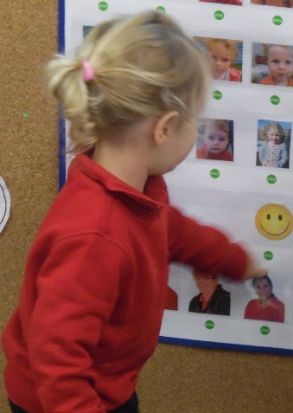
09.00- Welcome and registration
09.30- morning snack on offer
10.00-11.30 -Morning Learning ‘Busy Time’ play session between the indoor and outdoor areas. During this time some children may join with the adults for small group activities
11.45-11.55 - Brief tidy up
11.55-12.00 – Goodbye song for those leaving and hello song for those arriving
12.15 – Lunchtime
12.45-1.00pm – After Lunch rest/calm time activity
1.00-2.30pm – Afternoon learning “free flow” play session between the indoor and outdoor areas. During this time some children may join with the adults for small group activities
2.30-2.45pm – End of day Big tidy up time.
2.45-3.00pm – end of session quiet time/ story time/ activity and goodbye song before collection. Refreshments and snack offered.

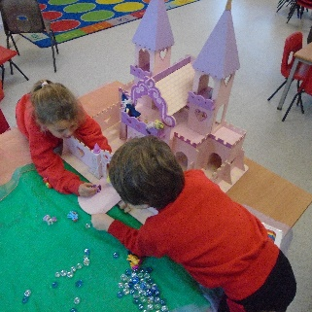
Curriculum

Our Curriculum is “Ambitious for all” We deliver a broad, stimulating, engaging and enriched curriculum that ignites children’s love of learning, sparks their imagination, develops thought-provoking responses and fosters a sense of awe and wonder. The Educational Programmes from the Statutory Framework for the Early Years Foundation Stage (DfE, 2021) underpins our core teaching and learning principles with a well-balanced approach of child initiated learning and adult led activities.

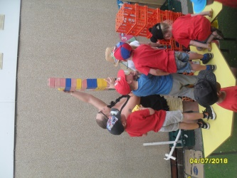
Each term the children are ‘hooked’ into a broad theme topic, taken from their current interests which enables Practitioner’s to nurture their natural curiosity where they are able to search for meaning and ask numerous question which then drives them into a deeper engagement of learning. The children are empowered to discover more, to explore and to become engrossed in learning that is self-directed. Practitioners enable children to maximise their learning through free-play explorations, focused explorations and enquiry-based learning opportunities.

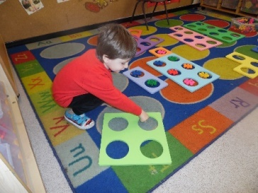
Our curriculum allows children to explore their own ideas, to test them and to push them to the furthest extremes, allowing them to develop skills such as concentration, resilience, perseverance, collaboration, communication and so much more. Children are central to the setting’s planning cycle; they share their thoughts, feelings and ideas with Practitioner’s and this is documented in our ‘floor books.’ They are able to record their learning, goals, aspirations and achievements; they recall their experiences and take ownership for their own education which in turn empowers them to become independent learners.
Assessments and Planning
The Early Years Foundation Stage (EYFS) has been reformed and there is a new EYFS framework that all schools and settings will follow from September 2025. These national changes have been made to better support all young children’s learning and development. Practitioners will now be spending less time on large amounts of written observations and assessments for evidence collection, enabling them to spend more time supporting and engaging with the children and their learning and development needs. We will also be following the non-statutory guidance called “Development Matters” to help us plan and deliver the curriculum.

The very first assessment will be prior to your child starting. We will ask you to complete a Parent Baseline, following the Development Matters document, to help us gauge an understanding of your childs current development and to plan for their Future learning. Practitioners will then observe the children engaged in a variety of activities, both child-initiated and adult-led, in order to make professional judgements about their stages of development within the different areas of the curriculum, Practitioners will use their experience and knowledge to monitor if a child’s learning and development is on track for their age.

Practitioners will work in close partnership with you, sharing these observations, highlighting your child’s achievements and also discussing any concerns if necessary.

We use an electronic learning journey (parenta) for each child using and using the assessment tool we document their learning journey. Upon registration we will assist you with setting up login details for this App. This system is completely secure and cannot be publicly viewed. Parents/Carers and other family members are encouraged to contribute to this learning journey by uploading comments and photographs of things the children have been doing at home.

Staff

All the staff at Coalway Early Years are qualified and highly experienced. All staff hold certificates in Child Protection/ safeguarding training and Paediatric First Aid. We are committed to the continuing professional development of our team, and staff members regularly attend external and internal training, meetings and forums to keep their knowledge and practice up to date. Full information about our staff team and structure can be found on our parent notice board and website. (www.coalwayearlyyears.co.uk)

Key Person Approach
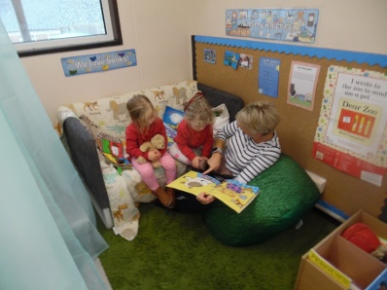
At Coalway Early Years we value strong, supportive partnerships with the children and families who use our service. When your child joins our playgroup, they will be assigned a key worker who will help to settle them in and spend time talking with you about your child’s needs, interests and abilities. They will act as your continuous main point of contact for any advice, support or information you may require whilst your child attends our playgroup. Your child’s key person/s will introduce themselves to you at the earliest opportunity after your child starts playgroup. You will also be able to see who your child’s key worker is on display in the rooms. This is called our Key person Board.

Committee

Coalway Early Years is a committee run, non-profit making charity. The committee are a group of volunteers, including parents, who hold regular, informal meetings to discuss the running of the group, help to make decisions based on our improvement plan, and oversee the nursery budget. If you are interested in volunteering for this role we invite you to contact Kayleigh Hoskings, our Manager. We are committed to safeguarding children and as such all volunteers are required to undergo a DBS check.

Partnership with Parents/Carers

Developing close, supportive partnerships with the parents and families of the children who attend our setting is a key part of our practice. At the enquiry and registration stage we will work closely with you to ensure we obtain detailed information about the needs and interests of your child and your aspirations for them.
We encourage parents and families to take an active part in supporting our playgroup. As a committee run charity, we rely heavily on fundraising to boost our income and run several activities linked to this throughout the year.

Some of the activities we currently offer to support our partnership with parents are:

- Free introductory sessions – we offer the opportunity for you and your child to visit the setting prior to starting with us and to join us for a short ‘taster’ sessions.
- Parents consultation meetings/open days – these may be linked to information sharing about our practice or curriculum; to discuss your child’s development, and to discuss transition to school when the time comes.
- Support for parents of children with special education needs and/or disabilities – our SEND Coordinator, Kayleigh Hoskings, will support you with making the right decisions for your child, sign-posting to other agencies, and creating plans for targeted support.
- Family Support – Kayleigh is also our family support for the setting and can help parents with a variety of issues, such as sign-posting to other agencies and support with routines at home such as toilet training and managing behaviour.
- Sharing of information – we ensure that you have access to lots of information about our day to day practice and your child’s development through notice boards, a Monthly newsletter, our website, Facebook page and your personal access to your child’s electronic learning journey via Tapestry.

Funding and Fees
Your child may be eligible for childcare funding according to their age and your circumstances. More information can be found regarding this by visiting our website. We accept the new government working parent entitlement for all children from age 2. Alternatively, you can email our manager, Kayleigh @ bcplaygroup@btinternet.com who will be happy to help you and answer any questions. Our fees for non-funded places are £7.15 for 2 year olds and £6.90 for 3 and 4 year olds.

Snacks and Lunches

During the morning the children are offered a healthy snack consisting of a choice of fruit and/or raw vegetables, a savoury item or cereal and milk or water to drink. Please can we ask you to provide a named bottle of water for your child so that we can ensure water is available to the children all day.

If your child stays for lunch you must provide them with a healthy choice lunchbox and a suitable drink. Please note that we do not permit fizzy drinks, chocolate, popcorn or sweets in children’s lunchboxes. We are also a nut free zone -please refrain from sending in peanut butter or chocolate spread.

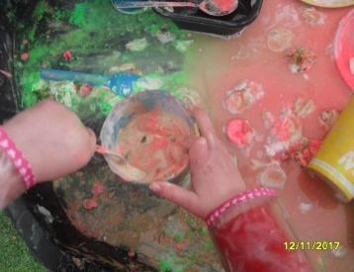
Clothing

We do have an optional uniform which can be purchased online via www.myclothing.com .
Please bear in mind that in line with the EYFS curriculum we actively encourage messy play that may include using sand, water, mud, paint, glue and other items – as such PLEASE do not send your child to playgroup in their best clothes! Although we do ask the children to wear protective clothing for messy play, inevitably at times they will get paint, mud, water etc on their clothes. We encourage your child to take part in these types of activities and we ask parents and carers to be supportive of this.

NB: Please provide a NAMED bag of NAMED spare clothes to be left at playgroup!
Please also ensure that your child comes to playgroup equipped for the weather as follows:

Autumn/Winter | Spring/Summer | Wet Weather
- Warm layers  - Warm, waterproof coat  - Hat, scarf, gloves (if very cold)   | - Light Layers  - A light waterproof coat for showers  - Sun hat  - A named bottle of sun-cream of factor 50   | - A named pair of wellies  - We provide full waterproof cover-ups for when the garden is very wet or muddy.  

Other equipment your child might need or wish to bring

- Nappies/pull-ups – if your child still wears nappies or pull-ups, we ask you to provide spare nappies, wet wipes and disposal bags in your child’s spare clothing bag. At the appropriate time, your child’s key person will work closely with you to support you and your child with toilet training.
- Medicine and medical equipment – if your child has a medical condition that requires treatment during their time at nursery (for example, asthma, skin conditions) you will need to inform us and complete appropriate medication paperwork. Asthma inhalers and any other on-going medication must be given to your child’s key person NOT left in their bag or drawer. If they require other periodic medication (such as antibiotics) we will ask you to complete a Short term medication form.
- Toys and comforters – IF your child requires a comforter/ toy to help them to settle we will allow them to bring these along to playgroup, however we cannot take responsibility if these items are left behind or lost. Key Persons will work with you to support your child with settling.

Policies
All our policies, which ensure that we abide by legal and statutory requirements and underpin the procedures of our practice can be viewed at the setting or via our website

Further information
For more information please visit our website at www.coalwayearlyyears.co.uk or our Facebook page.

If you have any queries please do not hesitate to get in touch. We look forward to welcoming you and your child to ‘Coalway Early Years’!

